Project Report

Strategic product placement analysis: unveiling sales impact with tableau visualization.

Date | 12 February 2026
Team ID | LTVIP2026TMIDS53841
Project Name | strategic product placement analysis: unveiling sales impact with tableau visualization.
Maximum Marks

INTRODUCTION

Project Overview
The Electric Car Analytics Dashboard project focuses on analysing global and Indian electric vehicle data to identify trends in brands, efficiency, pricing, body styles, and performance. The project uses data preprocessing techniques and Tableau visualizations to provide meaningful insights through interactive dashboards and stories.

Purpose
The purpose of this project is to analyse and visualize electric vehicle data to support better understanding of market trends, brand performance, and efficiency comparisons. It helps users make data-driven decisions through interactive filters, dashboards, and visual storytelling.

IDEATION PHASE

Problem Statement
The Electric Car Analytics project addresses challenges faced by first-time EV buyers and EV infrastructure investors in India. Buyers struggle with unclear real-world range data and scattered charging station information, leading to range anxiety and confusion. At the same time, investors lack integrated insights into EV sales trends and charging infrastructure gaps. This creates uncertainty in decision-making and highlights the need for a unified, data-driven analytical dashboard.
Customer Problem Statement Template: Problem Statement – 1: THE CAR BUYER
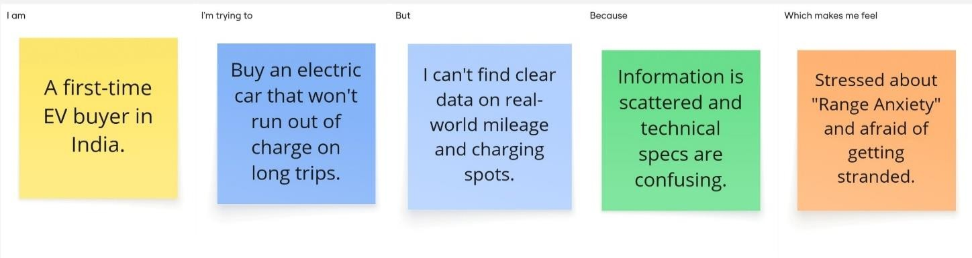

Problem Statement – 2: THE BUSINESS PLANNER
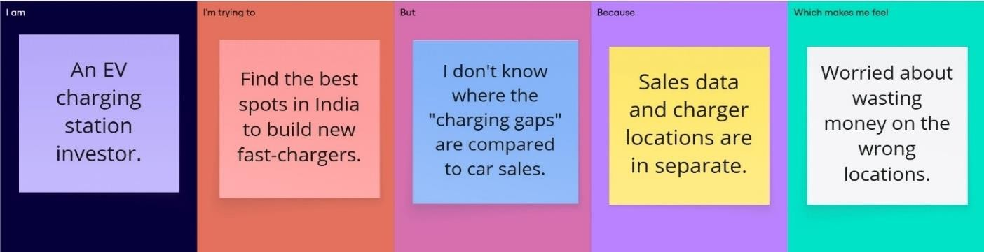

Problem Statement (PS) | I am (Customer) | I’m trying to | But | Because | Which makes me feel
The Car Buyer | A first-time EV buyer in India. | Buy an electric car that won't run out of charge on long trips. | I can't find clear data on real-world mileag and charging spots. | Information is scattered and technical specs are confusing. | Stressed about "Range Anxiety" and afraid of getting stranded.
The Business Planner | An EV charging station investor. | Find the best spots in India to build new fast- chargers. | I don't know where the "charging gaps" are compared to car sales. | Sales data and charger locations are in separate. | Worried about wasting money on the wrong locations.

Empathy Map Canvas

The Mind of an EV Enthusiast
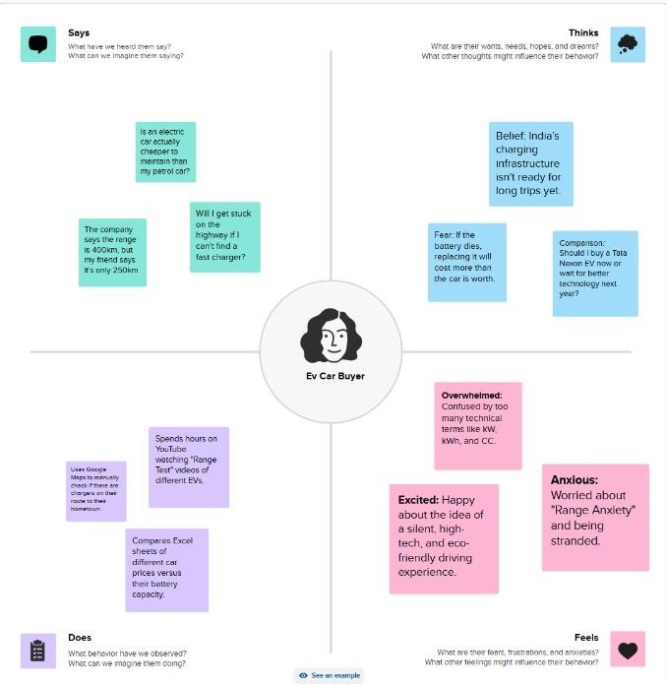

Brainstorming
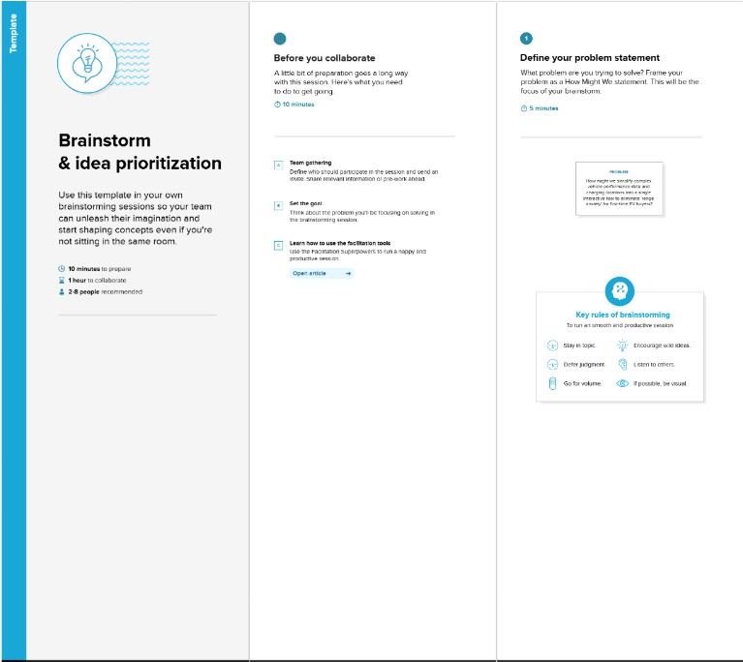
Step-1: Team Gathering, Collaboration and Select the Problem Statements
Step-2: Brainstorm, Idea Listing and Grouping
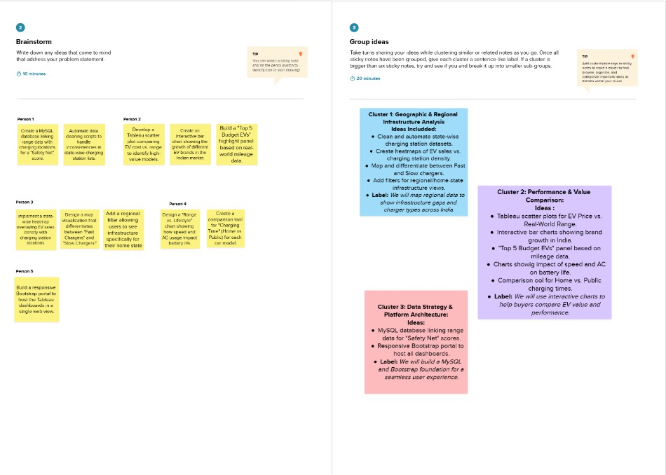
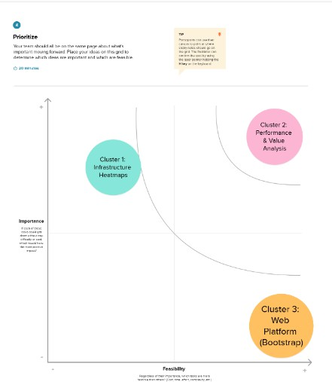
Step-3: Idea Prioritization

REQUIREMENT ANALYSIS

Customer Journey Map
The customer journey map outlines the experience of EV buyers and business planners while interacting with electric vehicle data. It identifies pain points such as range anxiety, scattered charging information, and lack of infrastructure insights. The journey highlights decision-making challenges and information gaps. This analysis helps define the exact needs of users. It ensures the dashboard is built to solve real- world problems effectively.
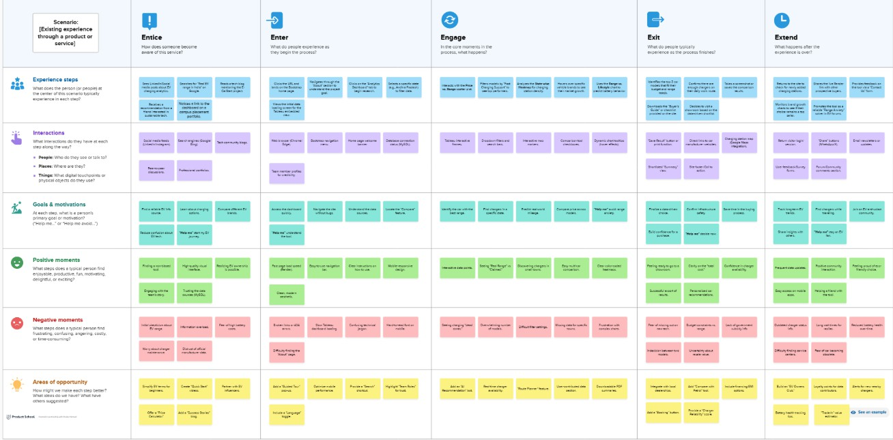

Solution Requirement
The solution requires an interactive dashboard that integrates EV sales, efficiency, pricing, and charging station data. It must provide clear visualizations and filtering options for easy analysis. The system should support comparative insights between brands and regions. Data accuracy and preprocessing are essential. The solution must be user-friendly and visually intuitive.

Functional Requirements:
Following are the functional requirements of the proposed solution.

FR No. | Functional Requirement (Epic) | Sub Requirement (Story / Sub-Task)
FR-1 | View Website | Access Home, About, Team & Contact sections
FR-2 | View EV Dashboard | Load EV Charging & Range Tableau Dashboard Display interactive charts  Responsive dashboard view
FR-3 | View EV Story | Load Tableau Story Navigate between story tabs
FR-4 | Contact Form | Submit user details Validate required fields  Display submission confirmation
FR-5 | Admin Data Management | Upload EV dataset to Tableau  Update dashboard visuals Publish dashboard

Non-functional Requirements:
Following are the non-functional requirements of the proposed solution.

FR No. | Non-Functional Requirement | Description
NFR-1 | Usability | The website should be user-friendly, easy to navigate, and visually clear with proper section alignment.
NFR-2 | Security | User contact data must be protected and not publicly exposed. Tableau dashboards should be securely embedded.
NFR-3 | Reliability | The system should consistently load dashboards and story without failure.
NFR-4 | Performance | The website should load within 3–5 seconds and dashboard rendering should be responsive.
NFR-5 | Availability | The system should be available 24/7 through web browsers.
NFR-6 | Scalability | The system should support addition of new datasets and future dashboard extensions.

Data Flow Diagram
A Data Flow Diagram (DFD) is a traditional visual representation of the information flows within a system. A neat and clear DFD can depict the right amount of the system requirement graphically. It shows how data enters and leaves the system, what changes the information, and where data is stored.
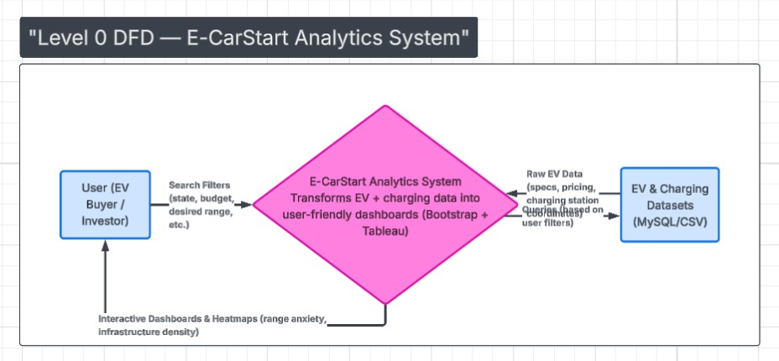

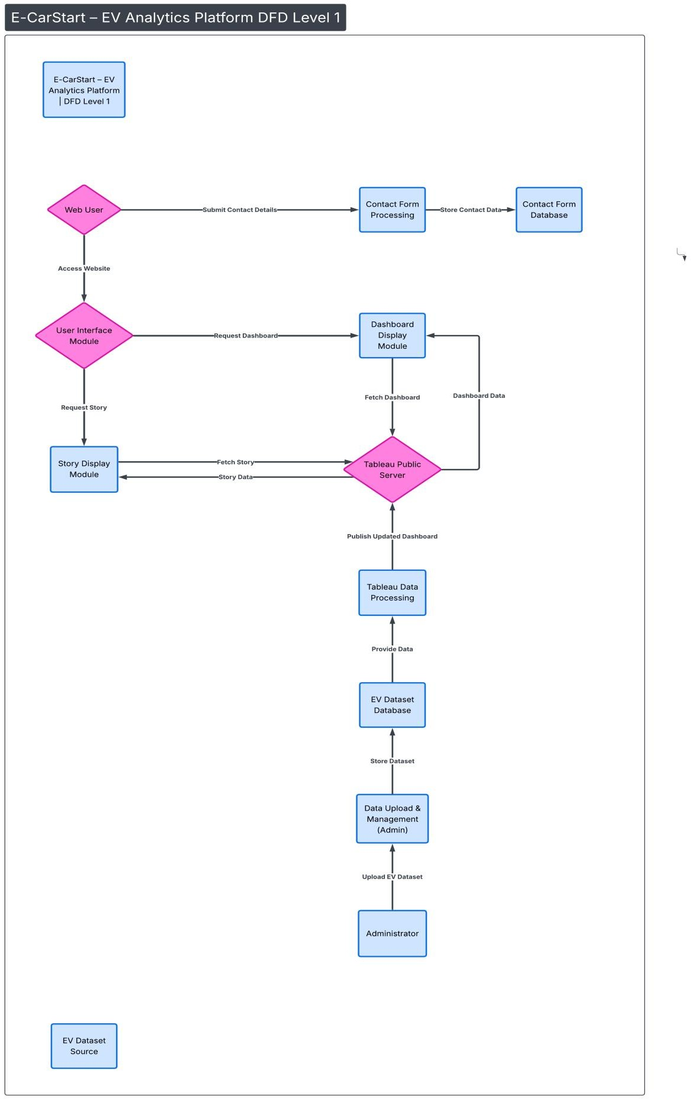

Technology Stack
The project uses Excel/CSV datasets for data storage. MySQL is used for database management and structured data storage. Tableau Desktop is used for data visualization and dashboard creation. Basic data preprocessing techniques are applied before visualization. These tools together ensure efficient data handling and presentation.
Table-1: Components & Technologies:

S. No | Component | Description | Technology
1. | User Interface | Web-based interface where users view EV dashboard, story and submit contact form | HTML, CSS, JavaScript, Bootstrap 5
2. | Application Logic – Dashboard Integration | Handles embedding and rendering of Tableau Dashboard inside the website. | JavaScript, Tableau Embed API
3. | Application Logic – Story Integration | Embeds Tableau Story and manages responsive display | JavaScript, Tableau Public
4. | Dataset Storage | EV dataset stored and processed within Tableau environment | Tableau Data Extract (TDE)
5. | File Storage | EV dataset files stored locally before upload to Tableau | Tableau Data Extract (TDE)
6. | Tableau Public API | Used to embed and display dashboard and story in website | Tableau Public Embed API
7. | Infrastructure (Web Hosting) | Website hosted on web server, dashboards hosted on Tableau Public Cloud: | Local Hosting / GitHub Pages / Render, Tableau Public Cloud

Table-2: Application Characteristics:

S.No | Characteristics | Description | Technology
1. | Open-Source Frameworks | Website built using open-source front- end frameworks | Bootstrap 5, HTML5, CSS3
2. | Security Implementations | Secure embedding of Tableau dashboards and form validation | HTTPS Protocol, Input Validation
3. | Scalable Architecture | Web-based modular structure allows addition of new dashboards and datasets | Modular Web Architecture, Cloud Hosting
4. | Availability | Dashboard available 24/7 via Tableau Public cloud | Tableau Public Cloud
5. | Performance | Optimized responsive UI and embedded dashboard loading | Bootstrap Grid System, Optimized Tableau Embed

- PROJECT DESIGN
  - Problem Solution Fit
The dashboard directly addresses range anxiety and infrastructure planning issues. It combines EV sales data with charging station insights. Buyers can compare efficiency and range, while investors can identify infrastructure gaps. The solution aligns with user pain points identified in requirement analysis. It ensures informed, data-driven decision-making.
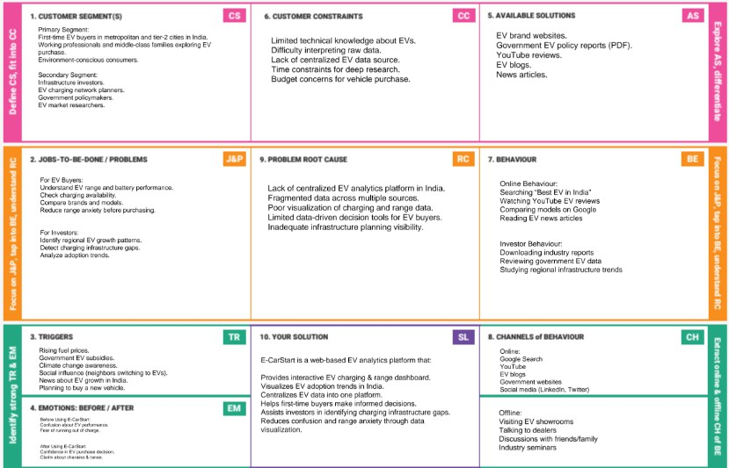

Proposed Solution
The proposed solution is an Electric Car Analytics Dashboard with multiple visualizations. It includes brand comparison charts, efficiency rankings, body style analysis, and summary cards. Interactive filters enhance user exploration. The dashboard is designed for clarity and simplicity. It transforms raw data into actionable insights.

S.No. | Parameter | Description
1. | Problem Statement (Problem to be solved) | First-time EV buyers in India lack centralized and reliable data about charging infrastructure and vehicle range, leading to confusion and range anxiety. Infrastructure investors also struggle to identify regional charging gaps due to fragmented information sources.
2. | Idea / Solution description | E-CarStart is a web-based EV analytics platform that provides interactive dashboards and visual stories about EV charging, range, and adoption trends. It centralizes data into an easy-to-understand format using Tableau and a responsive web interface.
3. | Novelty / Uniqueness | The platform combines EV charging, range, and market adoption insights into one interactive system focused on the Indian market. Unlike static reports or blogs, it offers real-time visual comparison and centralized analytics.
4. | Social Impact / Customer Satisfaction | E-CarStart promotes informed EV adoption, reducing range anxiety and increasing customer confidence. It also supports sustainable mobility by providing transparency in EV infrastructure growth.
5. | Business Model (Revenue Model) | The platform can adopt a freemium model with basic dashboards free and premium analytics for investors. Additional revenue can come from partnerships, advertisements, and data insight reports.
6. | Scalability of the Solution | The web-based modular architecture allows easy addition of new datasets and dashboards. It can scale to include real-time APIs, more regions, and advanced analytics features in the future.

Solution Architecture
The architecture follows a simple data pipeline structure. Raw EV datasets are collected and cleaned. Cleaned data is stored in a database. Tableau connects to the database to create visual dashboards. Users interact with the dashboard to generate insights.
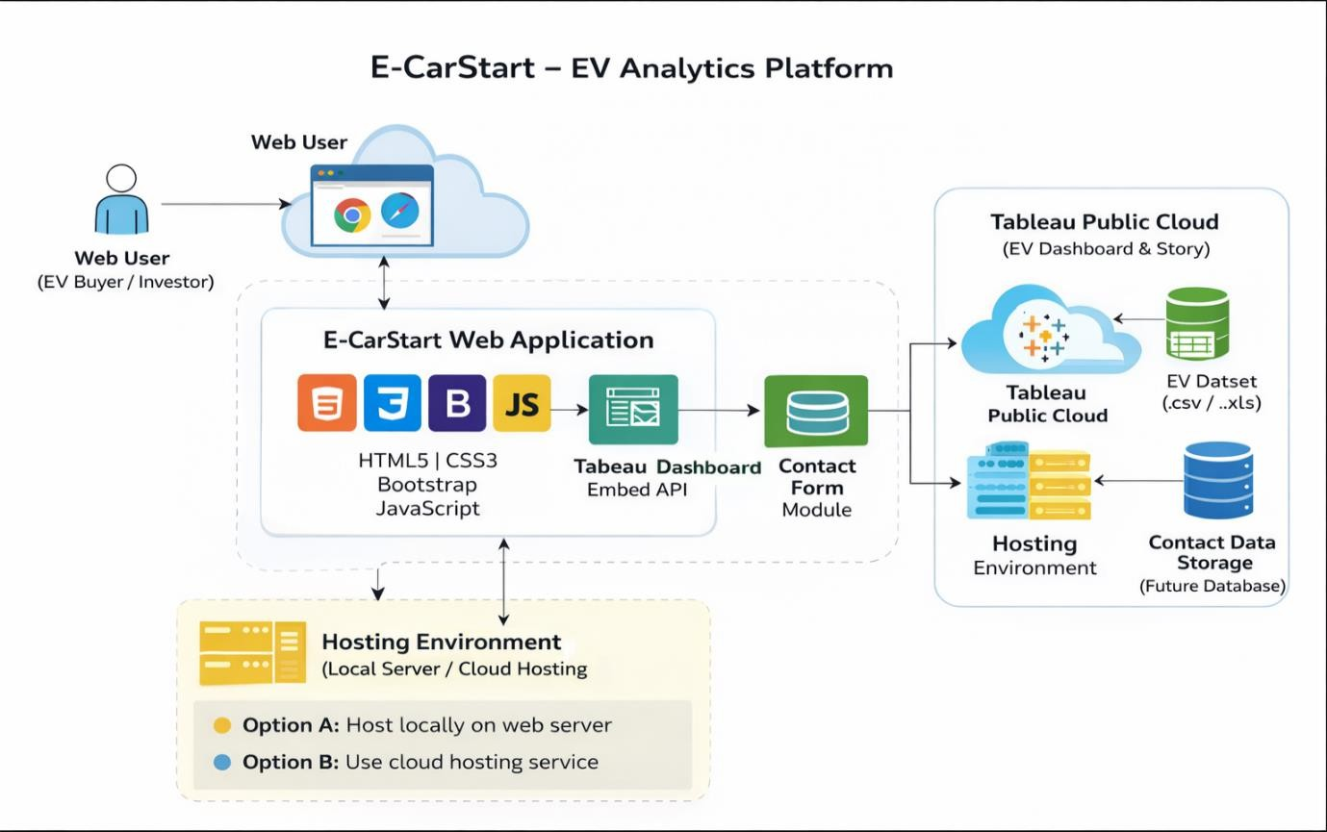

PROJECT PLANNING & SCHEDULING

Project Planning
The project was planned in stages: data collection, preprocessing, database integration, visualization, and testing. Each phase was executed sequentially. Timelines were set to ensure proper completion of tasks. Dashboard design and refinement were done iteratively. Proper planning ensured smooth execution.

Sprint | Functional Requirement (Epic) | User Story Number | User Story / Task | Story Points | Priority | Team Members
Sprint-  1 | Data Collection | USN-1 | Download EV dataset from  reliable source | 3 | High | P Jeevan
Sprint-  1 | Data Understanding | USN-2 | Analyse and understand dataset  attributes | 3 | High | K Dinesh
Sprint-  1 | Database Setup | USN-3 | Import dataset into database | 4 | High | R  Srikanth
Sprint-  1 | Tableau Connection | USN-4 | Connect Tableau Desktop to  database | 4 | High | N Akhila
Sprint-  1 | Data Preparation | USN-5 | Clean and prepare dataset for  visualization | 6 | High | M  Manasa
Sprint-  2 | Data Visualization | USN-6 | Create charts & EV analysis  visuals | 5 | High | K Dinesh
Sprint-  2 | Dashboard Creation | USN-7 | Design interactive dashboard | 5 | High | N Akhila
Sprint-  2 | Story Creation | USN-8 | Create EV analytics story in  Tableau | 3 | High | M  Manasa
Sprint-  2 | Publishing | USN-9 | Publish dashboard to Tableau  Public | 3 | High | P Jeevan
Sprint-  2 | Website Integration | USN-10 | Embed dashboard into website | 4 | High | R  Srikanth
Sprint-  3 | Website Navigation | USN-11 | Develop website sections | 4 | High | M  Manasa
Sprint-  3 | Contact Form | USN-12 | Implement form validation | 4 | High | R  Srikanth
Sprint-  3 | Responsive Design | USN-13 | Make website mobile responsive | 5 | Medium | K Dinesh
Sprint-  3 | Testing | USN-14 | Cross-browser testing | 3 | Medium | P Jeevan
Sprint-  3 | Final Review | USN-15 | Final deployment & bug fixing | 4 | High | All

Project Tracker, Velocity & Burndown Chart:

Sprint | Total Story Points | Duration | Sprint Start Date | Sprint End Date (Planned) | Story Points Completed (as on Planned End  Date) | Sprint Release Date (Actual)
Sprint-1 | 20 | 7 Days | 28 Jan 2026 | 03 Feb 2026 | 20 | 03 Feb 2026
Sprint-2 | 20 | 7 Days | 04 Feb 2026 | 10 Feb 2026 | 20 | 10 Feb 2026
Sprint-3 | 20 | 7 Days | 11 Feb 2026 | 14 Feb 2026 | 20 | 14 Feb 2026

AV = Sprint duration/velocity =20/7= 2.85 ~ 3 story points per day

FUNCTIONAL AND PERFORMANCE TESTING

Performance Testing
The dashboard was tested for responsiveness and accuracy. Filters and interactive features were validated. Data consistency between database and visualizations was checked. Performance was monitored for loading time and smooth interaction. The system performs efficiently for the given dataset size.

S.No. | Parameter | Screenshot / Values
1. | Data Rendered | The EV dataset was successfully rendered in Tableau Desktop. All fields including vehicle type, charging time, range, state, and price were loaded correctly without errors.  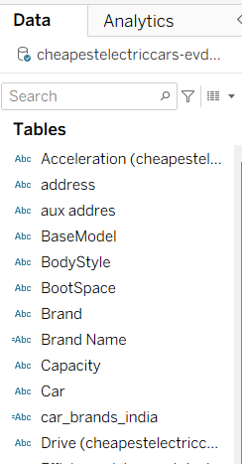
2. | Data Preprocessing | Data preprocessing was performed by handling missing values, removing duplicate records, correcting data types, and creating calculated fields. Units were standardized and unnecessary columns were removed before visualization.  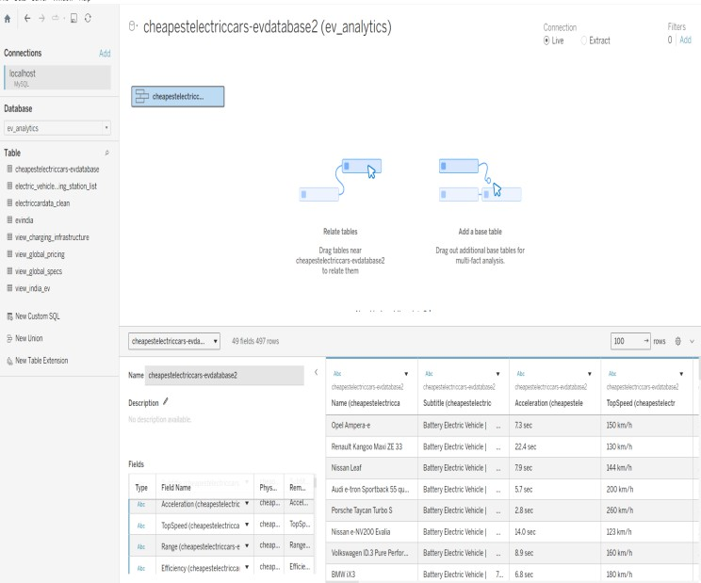

3. | Utilization of Filters | Filters such as Style, Vehicle Type, Charging Type, and Range were applied to enable dynamic interaction in the dashboard.  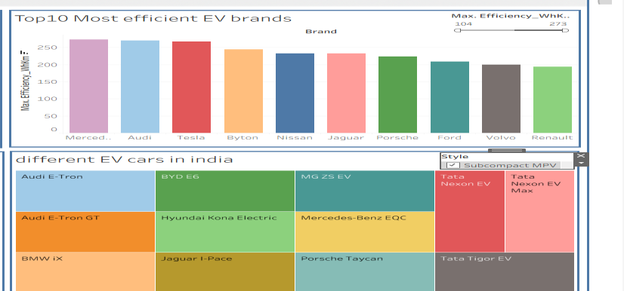
4. | Calculation fields Used | AVG([Range])  COUNT([Vehicle Type])
5. | Dashboard design | No of Visualizations / Graphs – 5  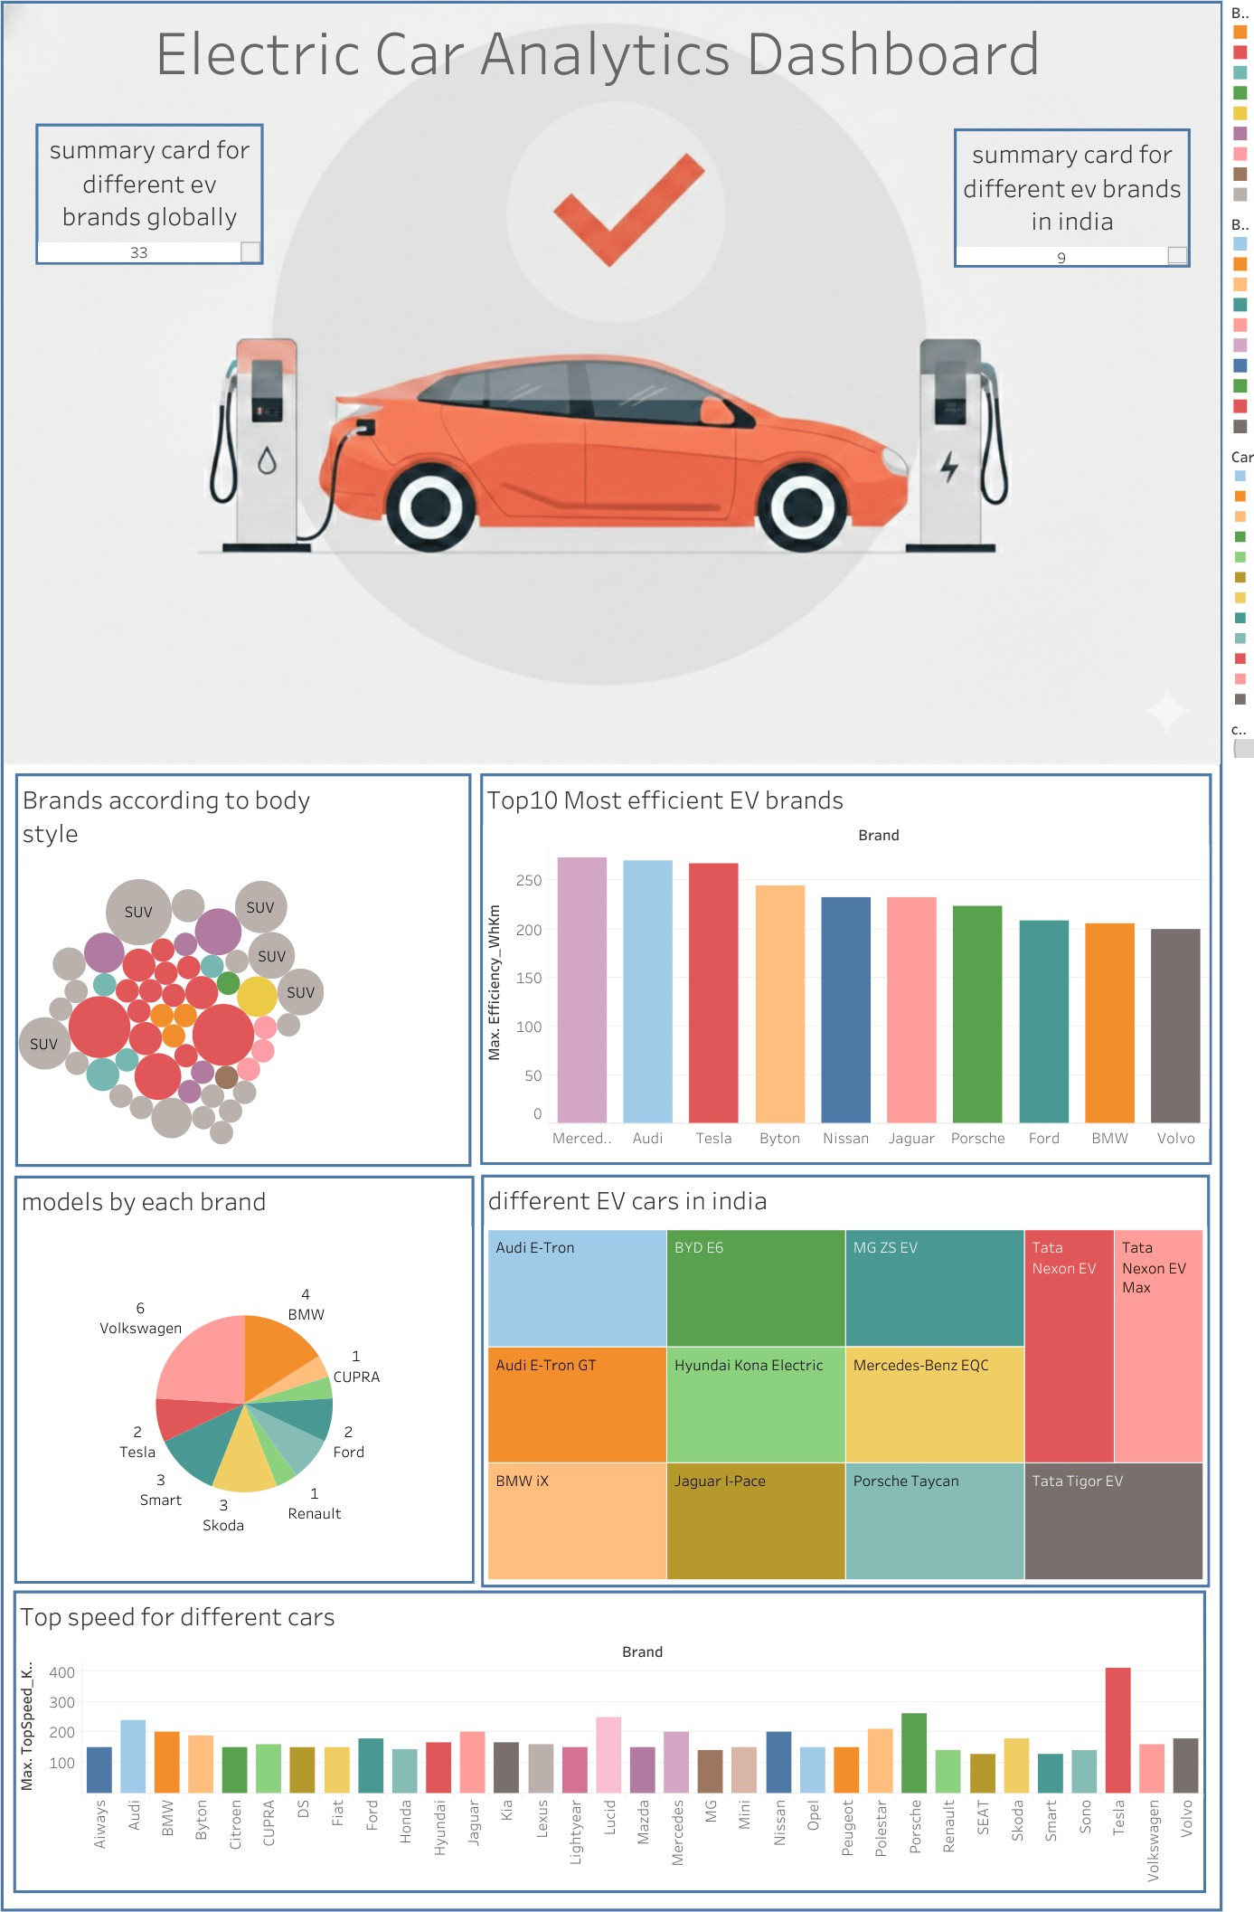
6 | Story Design | No of Visualizations / Graphs – 4  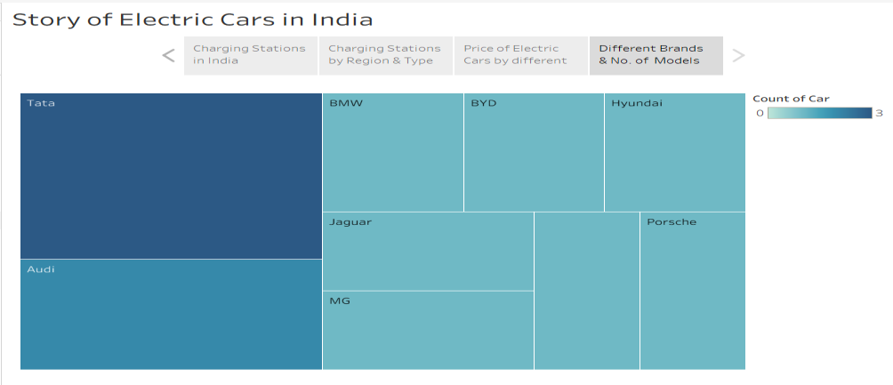

RESULTS

Output Screenshots
The final dashboard displays EV brand analysis, efficiency comparisons, and body style distribution. Summary cards highlight key metrics. Filters allow dynamic exploration of data. Visualizations provide clear and actionable insights. The results demonstrate successful implementation of the project objectives.

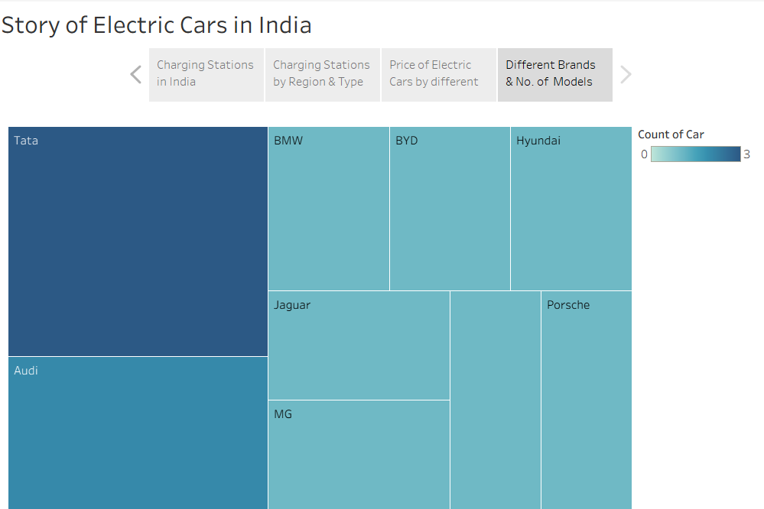

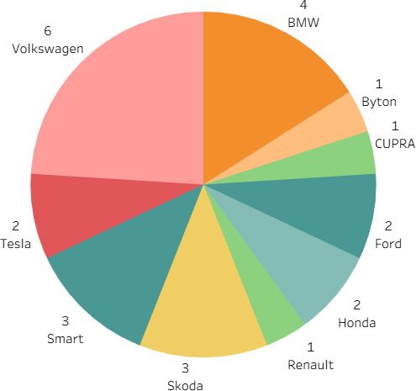

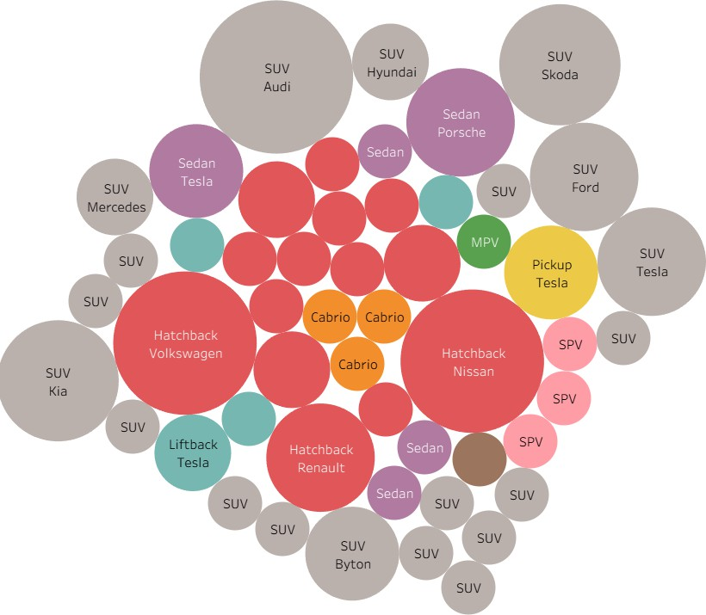

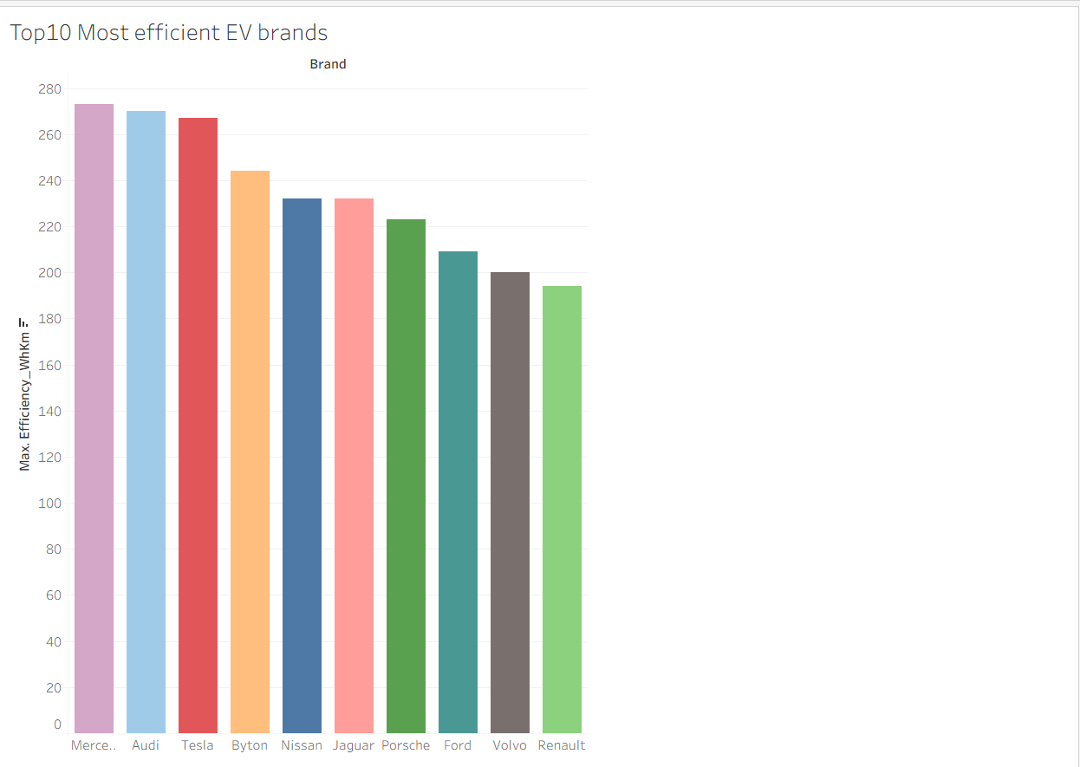

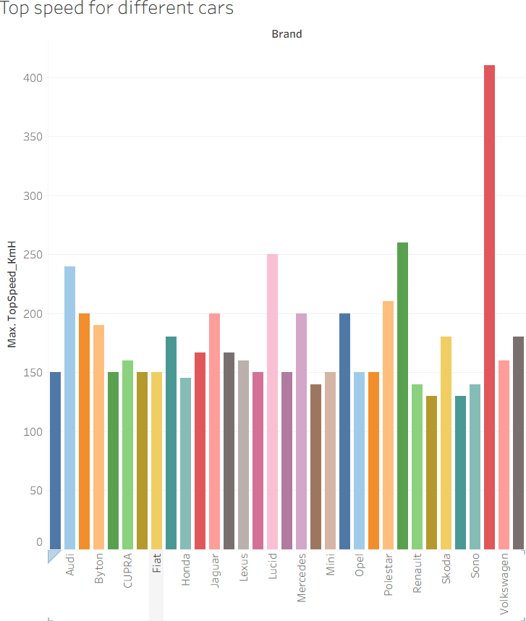

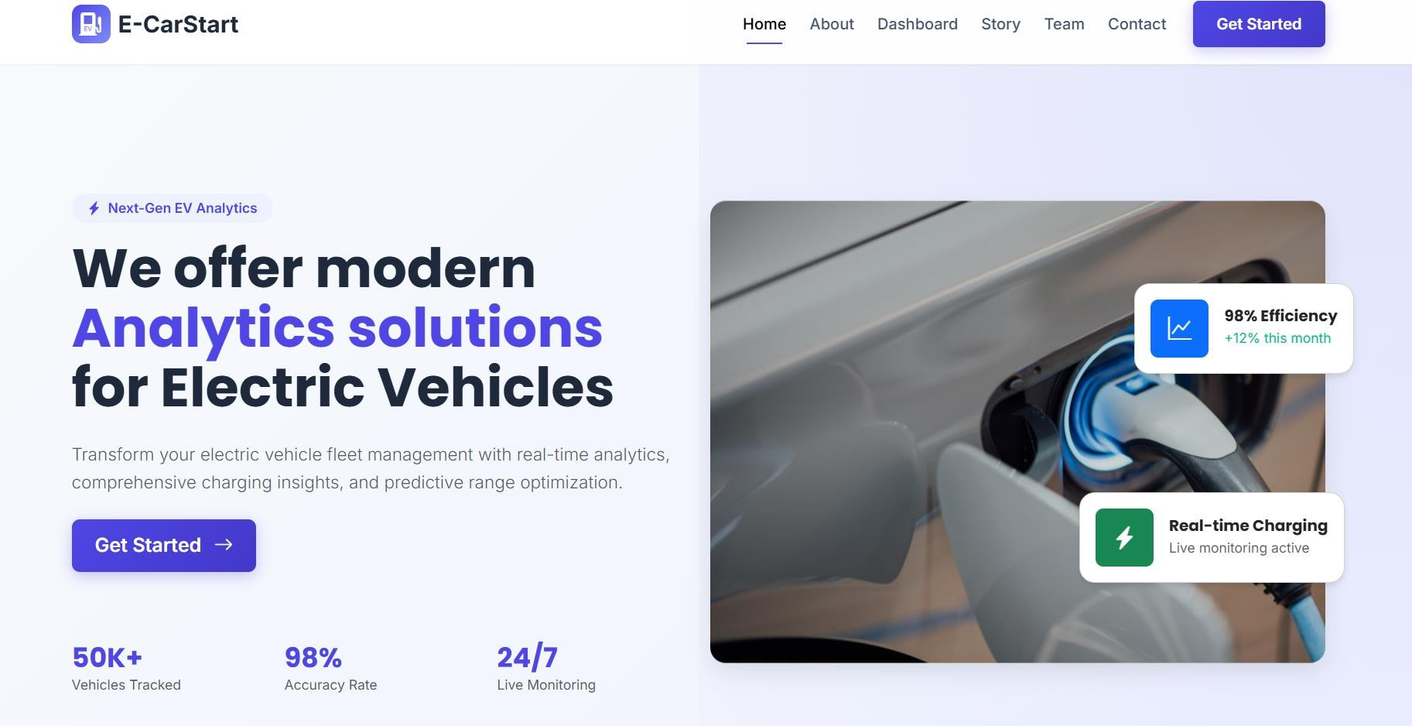

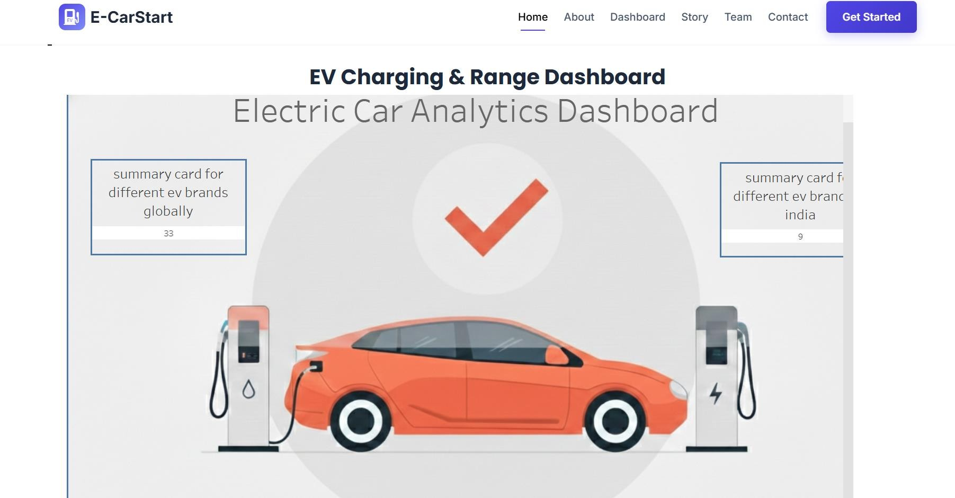

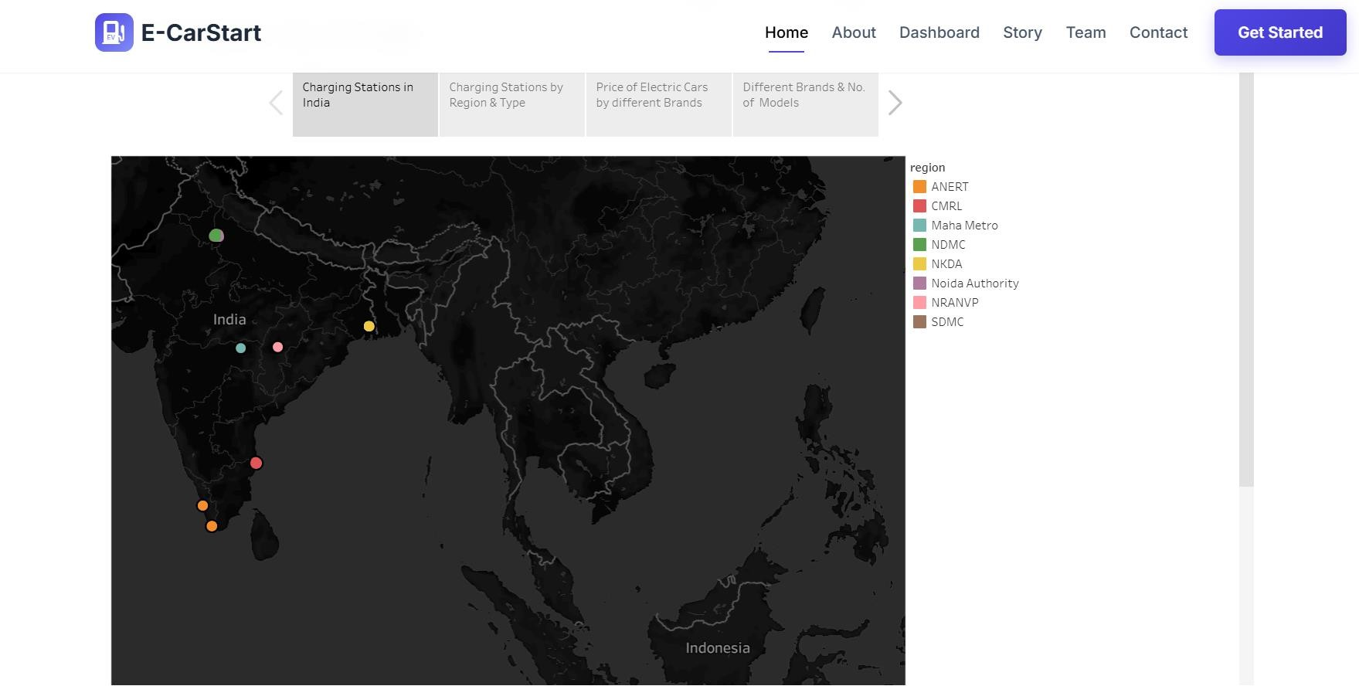

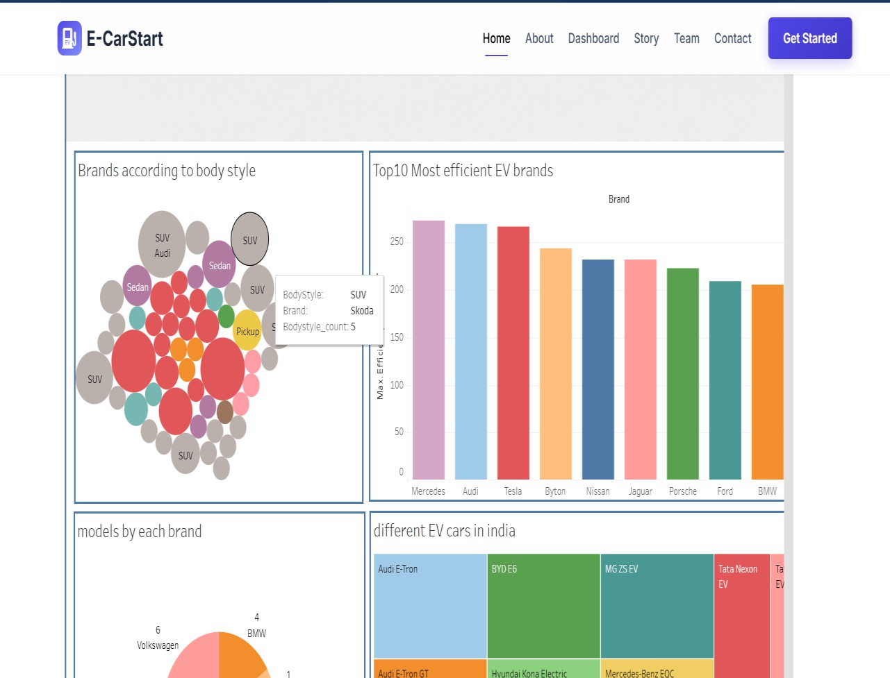

ADVANTAGES & DISADVANTAGES

Advantages:
The dashboard provides centralized EV insights. It simplifies complex technical data. Interactive filters improve usability. It supports data-driven decisions for buyers and investors.

Disadvantages:
The project depends on dataset accuracy. Real-time data updates are not included. Limited to available dataset scope. Large datasets may affect performance.

CONCLUSION
The Electric Car Analytics Dashboard successfully integrates EV data into meaningful visual insights. It addresses both consumer and investor challenges. The project demonstrates effective data preprocessing, database integration, and visualization techniques. It enhances decision-making through interactive dashboards. Overall, it meets the intended objectives efficiently.

FUTURE SCOPE
The project can be extended with real-time EV and charging station data. Predictive analytics can be added for future sales forecasting. Integration with live APIs can improve accuracy. Geographic map visualizations can enhance infrastructure planning. The system can also be deployed as a web-based analytics platform

APPENDIX
Dataset Link:
https://drive.google.com/file/d/1MfFZUAyT1AmziX_y3PHEeawX3CO6uRTz/view?usp=sharing

Github Documentation Link:
https://github.com/Hemakiran1/strategic-product-placement-analysis-unveiling-sales-impact-with-tableau

Github Project Link:
https://github.com/Hemakiran1/strategic-product-placement-analysis-unveiling-sales-impact-with-tableau

Project Demo Link:
https://drive.google.com/file/d/1IWD354RgFtvETDgjZEImZgptFMsTTAmJ/view?usp=sharing

